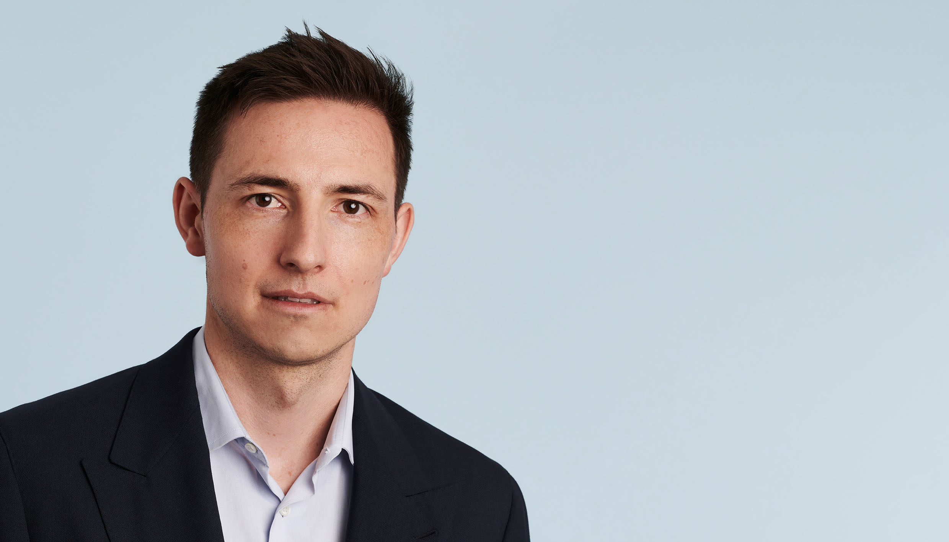
Expertise
Adrian Koller
Partner, lic. iur., Attorney-at-law, LL.M.
adrian.koller@nkf.ch
D +41 58 800 83 93
M +41 79 851 28 30
Languages
German, English
Adrian Koller is a member of the Transactions Team of Niederer Kraft Frey and focuses mainly on public and private M&A as well as financing transactions, including complex acquisition, leveraged and syndicated financing. In addition, Adrian advises on capital markets transactions and other corporate and commercial law matters.
Furthermore, Adrian is a member of the editorial board of a legal periodical on Swiss corporate and capital markets law GesKR (Schweizerische Zeitschrift für Gesellschafts- und Kapitalmarktrecht).

Banking, Finance & Regulatory Corporate / M&A Commercial Capital Markets Private Equity x
Career
2021 Partner, Niederer Kraft Frey
2018 Senior Associate, Niederer Kraft Frey
2013 Associate with a major law firm in Zurich
2010 Junior associate with a major law firm in Zurich
2007 Assistant to the editorial board of the Swiss law journal on corporate and capital
markets law (GesKR)
Education
2013 Admitted to the Bar (Rechtsanwalt)
2013 Kent College of Law Chicago, LL.M. in International Financial Services Law
2010 University of Zurich, lic. iur.
Experience
Recent public matters in which Adrian Koller acted as counsel to:*
- EQT Private Equity on the sale of a majority stake in VFS Global (2021)
- Leoni AG board member and LEONI Studer AG CEO Bruno Fankhauser regarding the acquisition of Leoni Schweiz AG from Leoni AG by a consortium of buyers led by Bruno Fankhauser and Helvetica Capital AG (2021)
- Calibre Scientific, Inc., (Calibre Scientific) on the acquisition of HUBERLAB.AG (2021)
- Credit Suisse (Switzerland) Ltd., ING Bank N.V. and the syndicate on the landmark refinancing of Green's existing credit facilities agreement (2021)
- Franke Group on the carve-out and sale of its division Franke Water Systems to Equistone (2021)
- Zürcher Kantonalbank and the banking syndicate on the refinancing of Swisscom AG (2021)
- The steering committee of the lenders of Benteler Group, comprising Commerzbank AG, DZ BANK AG, Erste Group Bank AG, Landesbank Baden-Württemberg, and Norddeutsche Landesbank on the now completed full refinancing, which is part of a fundamental restructuring of Benteler Group (2021)
- Credit Suisse (Switzerland) Ltd. acting as sole lender in the financing of SIX Swiss Exchange listed SGS SA's acquisition of SYNLAB Analytics & Services from SYNLAB (2021)
- UBS Switzerland AG, Credit Suisse (Switzerland) Ltd. and Zürcher Kantonalbank on the refinancing of Arbonia AG (2020)
- Morgan Stanley Capital Partners on the closing of the investment in US HealthConnect (2020)
- CGS Management on the acquisition of Kalt Maschinenbau AG (2020)
- Ardian on the acquisition of a majority stake in Swissbit Holding AG (2020)
- Mitsubishi Corporation on the acquisition of a minority stake in Spanish vehicle distributor Bergé Automoción, S.L. (2020)
- Invision AG on the add-on acquisition by its portfolio company IDAK HOLDING AG of a majority stake in Margherita S.R.L. (2020)
- Global Blue and Silverlake on the USD 2.6bn business combination with Far Point Acquisition Corporation (2020)
- EQT on the acquisition of a minority stake in SHL Medical (2020)
- Lindsay Goldberg on the acquisition of the Bilcare Research Group (2019)
- The agent, the security agent and the note purchasers on the second lien financing for the acquisition of Nestlé Skin Health by EQT and Abu Dhabi Investment Authority (ADIA) (2019)
- Steinhoff Europe AG on the implementation of its corporate and financial restructuring (2019)
- Invision Private Equity on the amplification of the shareholding circle of the Schneider Group, one of the leading internationally focused Swiss transportation companies (2019)
- The lenders and export credit agencies (including EIB, EBRD, COFACE, SACE and Euler Hermes) on the financing of Trans Adriatic Pipeline (TAP) (2019)
- Capvis Equity V LP on the acquisition of a majority stake in Variosystems AG (2018)
- Former shareholders of Heptagon on the sale and completion of Heptagon to ams (2018)
- EQT and Kuoni Group on the sale of Kuoni's Global Travel Services to the JTB Corporation (2017)
- EQT and Kuoni Group on the sale of Kuoni's Destination Management Specialists to Thomas Cook India (2017)
- EQT and Kuoni Group on the combination of Kuoni's GTA Business with Hotelbeds Group (2017)
- CVC on the acquisition financing of its acquisition of a majority stake in Breitling (2017)
- Heptagon Advanced Micro-Optics and its shareholders on the sale of Heptagon to ams (2016)
- CSA Energy-Infrastructure Switzerland on acquisition of a stake in Erdgas Obersee (2016)
- CSA Energy Infrastructure Switzerland on its acquisition of a stake in the Swiss Transitgas Pipeline (2016)
- EQT on its public tender offer for Kuoni Travel Holding (2016)
- CSA Energy Infrastructure Switzerland on the acquisition of an equity stake in Romande Energie Holding SA (2016)
- African Bank Limited on its successful restructuring and re-launch (2016)
- KKR on the acquisition of a 25% stake in SoftwareONE (2015)
- Enagás and Fluxys on its acquisition of a stake in Trans Adriatic Pipeline (2014)
- UBS and the other syndicate members on the CHF 438 million rights offering of Schmolz + Bickenbach AG (2013)
- Barry Callebaut on its acquisition finance, including a credit facilities agreement and the placement of shares by way of an accelerated bookbuilding, to finance the acquisition of Cocoa Ingredients Division from Petra Foods (2013)
- Credit Suisse on the acquisition financing for HDTL Holding SA and Pronia in connection with their acquisition of the La Tour Hospital Group (2013)
- Waterland Private Equity and SENIOcare Group on its CHF 56 million debt refinancing (2013)
*Transactions before 2018 while working at another major Swiss law firm
Publications
- Till Spillmann, Adrian Koller, Andrea Giger, Ivo von Büren, Lending and taking security in Switzerland, in: Thomson Reuters Practical Law 2016
- Till Spillmann, Adrian Koller, Intra-group financing, in: IFLR Magazine, February 2016
Market Perception
Adrian Koller has very strong commercial awareness and vision. His level of sophistication is very strong. (Chambers 2024 - Restructuring/Insolvency)
Adrian Koller was always approachable and his advice was always on point. He has very strong commercial awareness and vision. (Chambers Global 2023)
Adrian Koller is "a proactive, hardworking and very knowledgeable lawyer" who "pays great attention to detail" and possesses "excellent commercial acumen", excelling in sophisticated banking and project finance transactions. (Who's Who Legal 2022)
Adrian Koller really made a very good impression. We worked super-quickly and stuck to the timelines and the budget. It really was a pleasure working with him. (Chambers Global 2022)
Adrian Koller is looked upon with enormous favour for his skilful handling of high-value acquisitions and refinancings. (Who's Who Legal 2021)
"Very accessible, fast and on time, quick understanding of the issues at stake, excellent knowledge of the business." (IFLR 1000 2020/2021)
"Adrian Koller is extremely responsive and has an extremely good legal understanding. Further, he
has a very good ability to explain complex legal questions with rather simple words." (IFLR 1000 2020/2021)

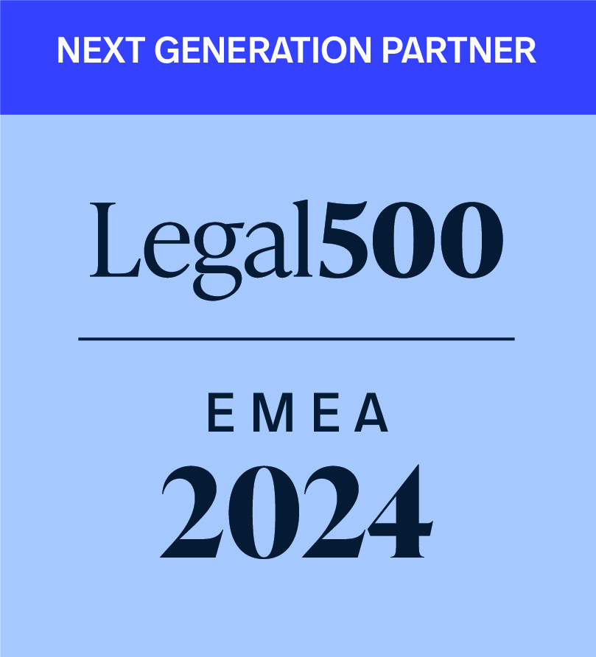 | 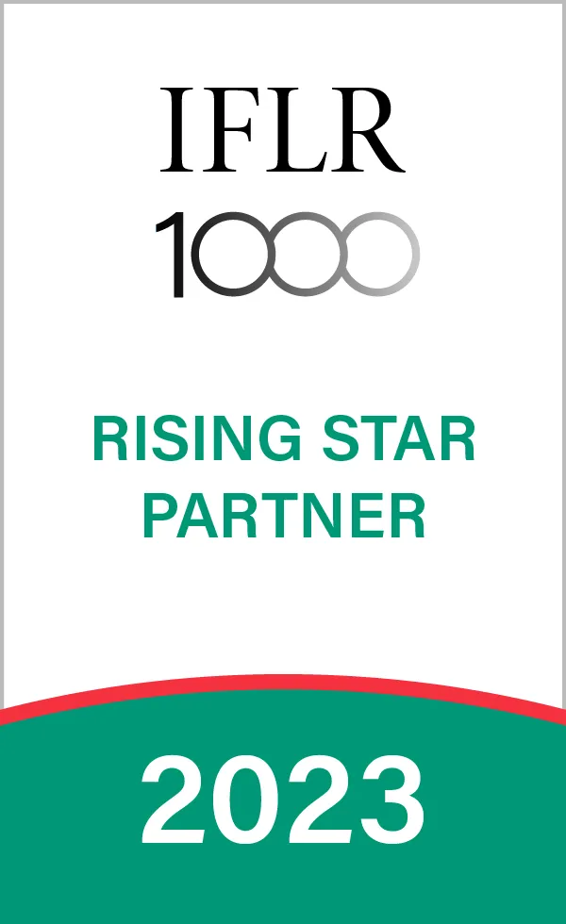 | 